Passive Voice:

Рафи Цигаров

№ 2201261077 Информатика 1 курс

1 by

2 with

3 by

4 by

5 with

6 with

7 with

1 blown

2 haven`t

3 been

4 has

5 be

6 awarded

7 is

8 by

1 C

2 D

3 A

4 B

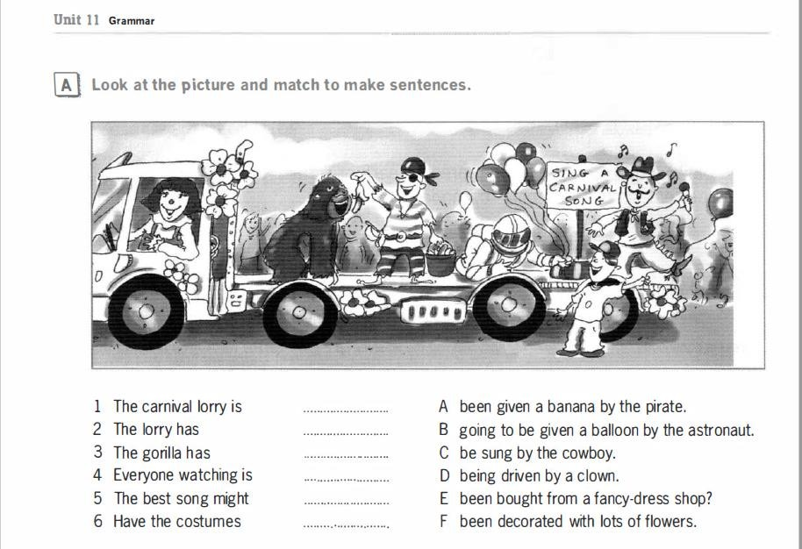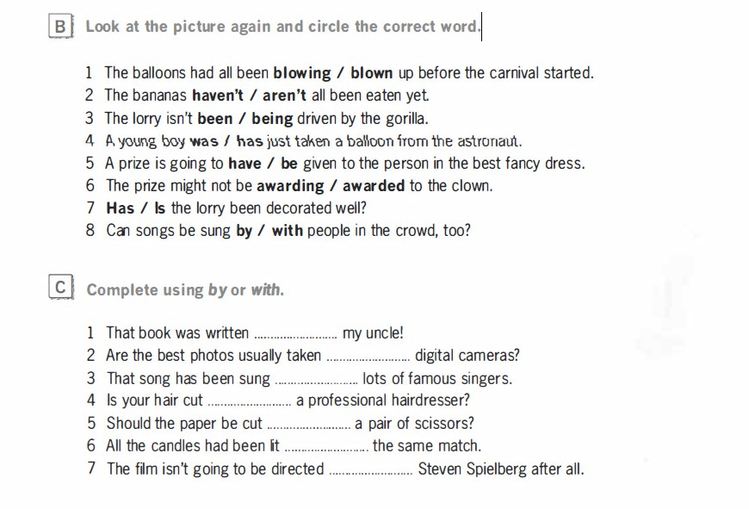

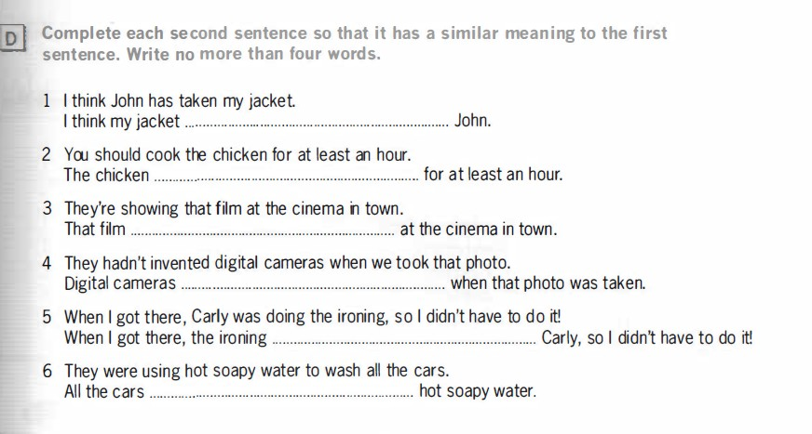

1 was taken by

2 shoud be cooked

3 is showing

4 haven`t been invented

5 was done

6 were washed with

:

Comparative and Superlative Forms of Adjectives

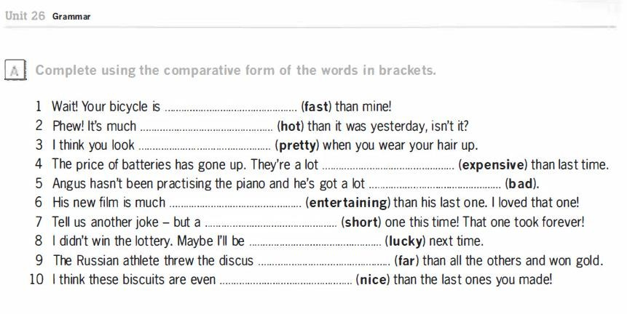

shorter

nicer

further

luckier

more intertaining

faster

hotter

prettier

worse

more expensive

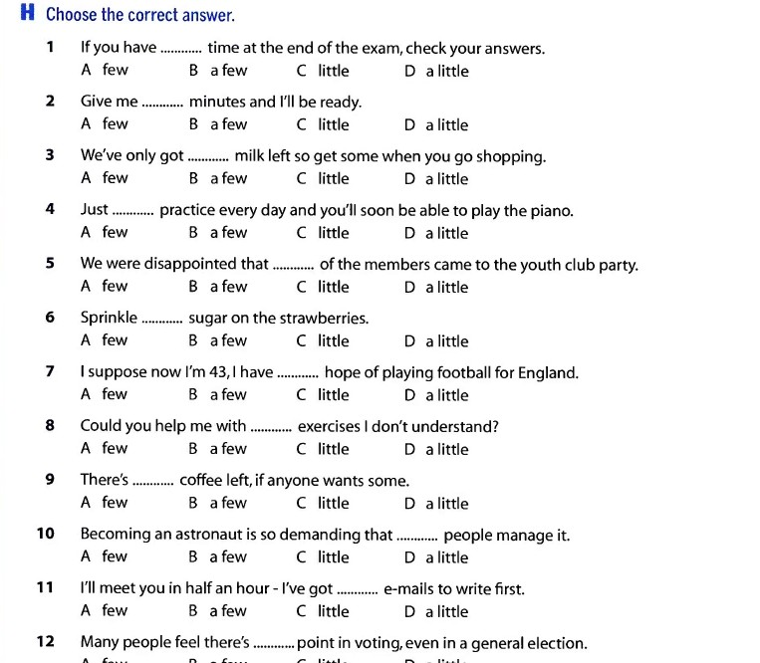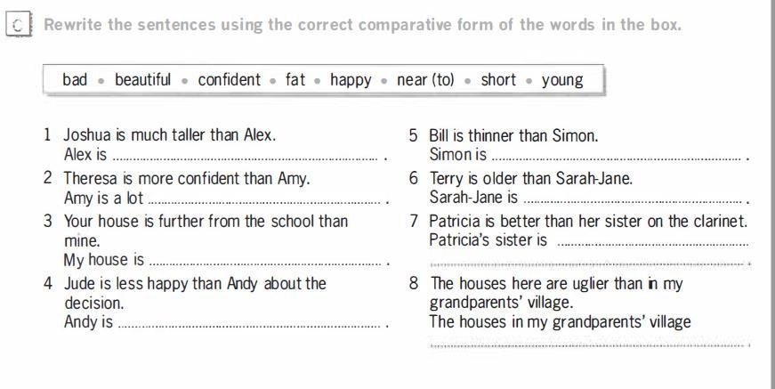

are more beautiful than the houses here

worse than her sister on the clarinet

shorter than Joshua

is younger than Terry

fatter than Bill

happier than Jude about the decision

nearer to the school than mine

less confident than Theresa

Quantifiers:

1 – D

2 – B

3 – D

4 – D

5 – A

6 – D

7 – C

8 – B

9 – D

10 – A

11 - A

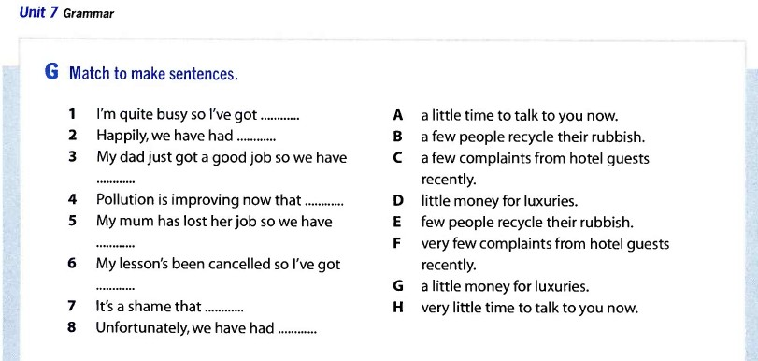

1 – H

2 – F

3 – G

4 – D

5 – B

6 – A

7 – E

8 - C

Modal Verbs:

C – had to

C – have forgotten

B – be able to

A – need

D – shouldn`t

B – didn`t have to

D – Could

10 – play

9 - able

7 - have got

3- be able to

1 - speak

2 - 

4 - could

5 - could

6 - could

8 - could

D – have been working

Не виждам другите варианти

Не виждам другите варианти

